Task 1: Enable CloudTrail monitoring and store the events in S3 and CloudWatch Logs

Objective
Capture all AWS API activities using CloudTrail and store them in both an S3 bucket and CloudWatch Logs.

Implementation Steps

Step 1: Create an S3 Bucket
- Login to AWS Console.
- Open S3.
- Click Create bucket.
- Give a unique bucket name.
Example:
cloudtrail-log-bucket-0549
- Select the same Region.
- Leave remaining settings as default.
- Create the bucket.
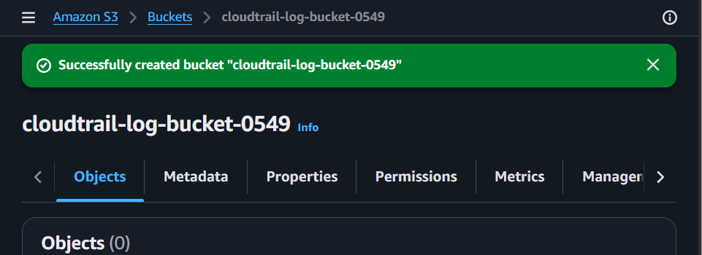

Step 2: Create CloudWatch Log Group
- Open CloudWatch
- Select Log Groups
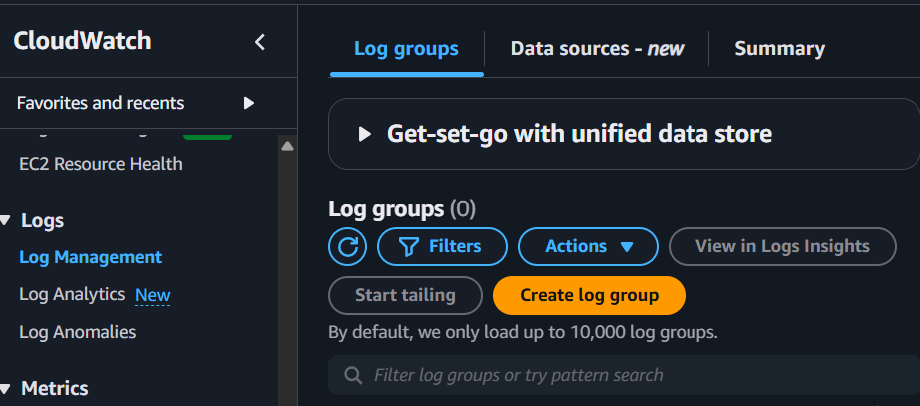
- Click Create log group
- Name it
CloudTrailLogs
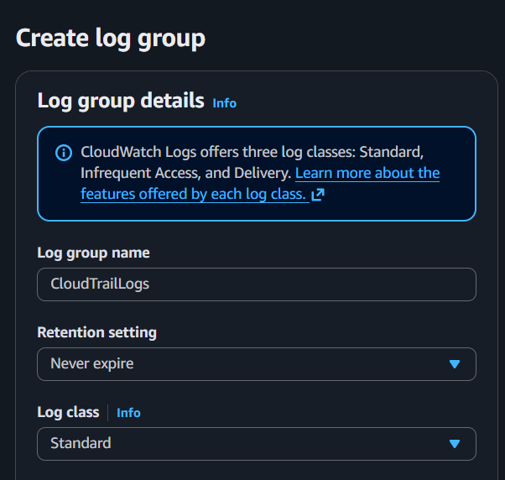
- Create.
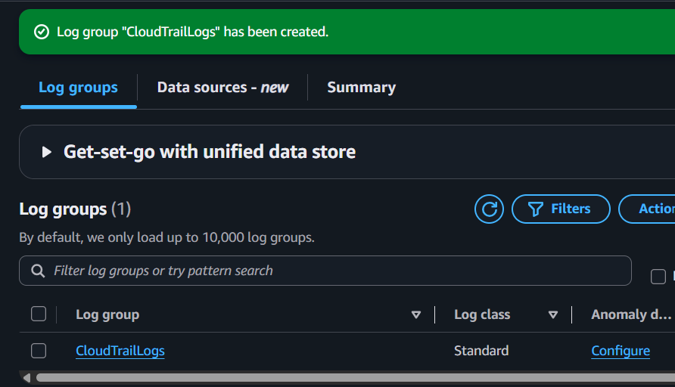

Step 3: Create a CloudTrail Trail
- Open CloudTrail.
- Click Create trail.
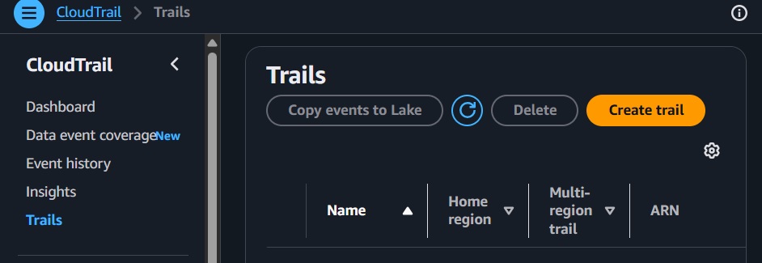
- Enter the Trail name.
Example:
OrganizationTrail
- Under Storage location, choose:
Use existing S3 bucket
- Select the S3 bucket created earlier.
Example:
cloudtrail-log-bucket-0549
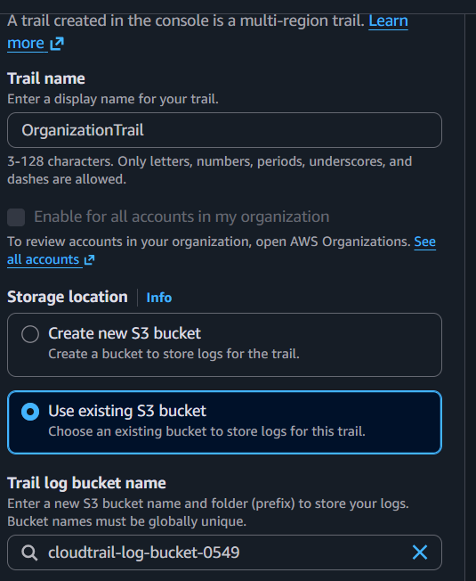

Step 4: Enable CloudWatch Logs
- Scroll down to the CloudWatch Logs section.
- Enable CloudWatch Logs integration.
- Select the log group created earlier.
Example:
CloudTrailLogs
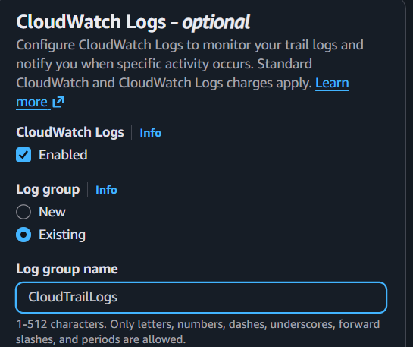
- Under IAM Role, click:
Create new IAM role
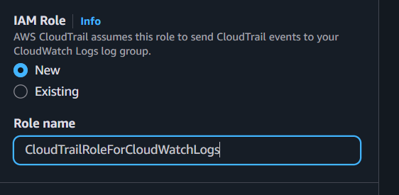
Note: AWS automatically creates the required IAM role with the necessary permissions to publish CloudTrail logs to CloudWatch Logs. There is no need to manually create the role from the IAM console.

Step 5: Configure Event Type
Choose the following options:
Management Events
✓ Read
✓ Write
Leave the remaining settings as default.
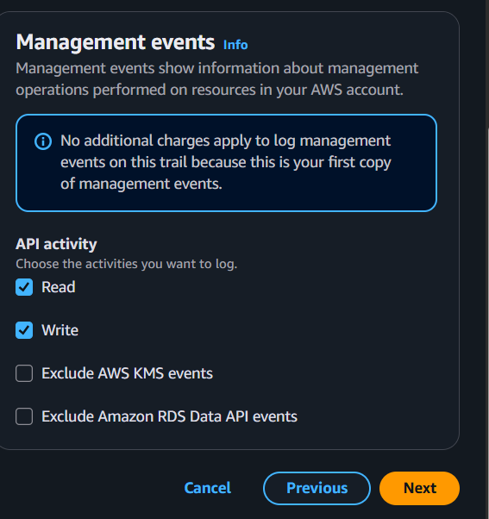
Click Create trail.
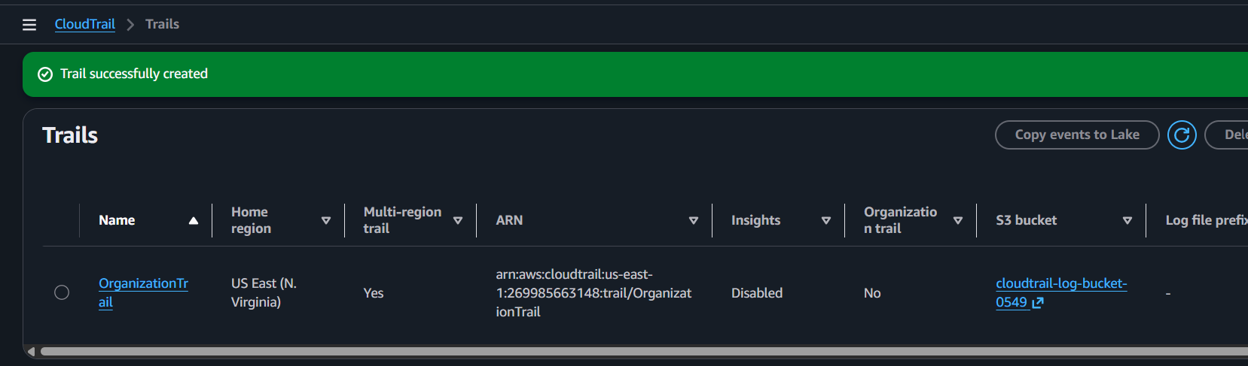

Step 6: Generate CloudTrail Events
Perform any AWS activity to generate CloudTrail events.
Examples:
- Launch an EC2 instance
- Stop or Start an EC2 instance
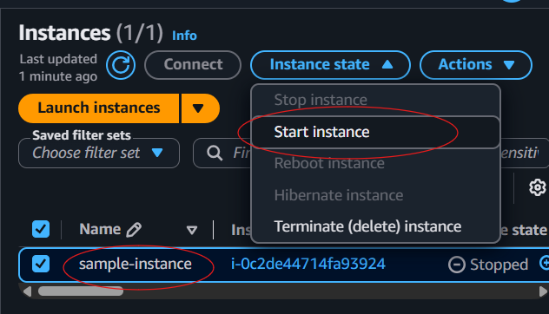
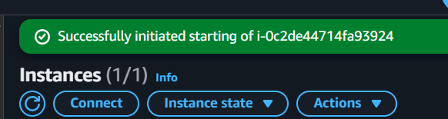
- Create an S3 bucket
- Create an IAM user
- Delete an S3 object
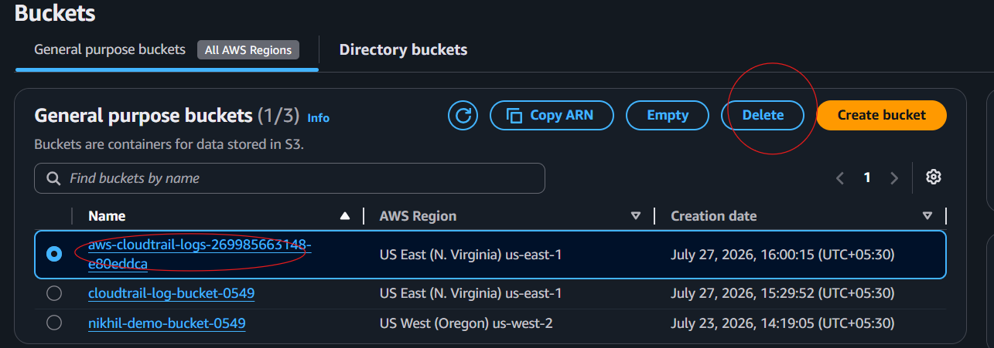
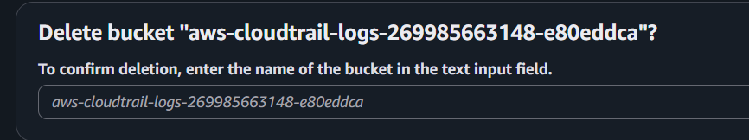
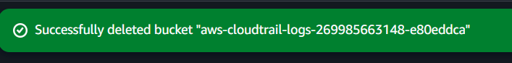

Validation Steps

Validation 1: Verify Logs in S3
- Open Amazon S3.
- Open the CloudTrail bucket.
Example:
cloudtrail-log-bucket-12345
- Navigate to:
AWSLogs
└── Account-ID
└── CloudTrail
Expected Result:
CloudTrail log files are available in the bucket.
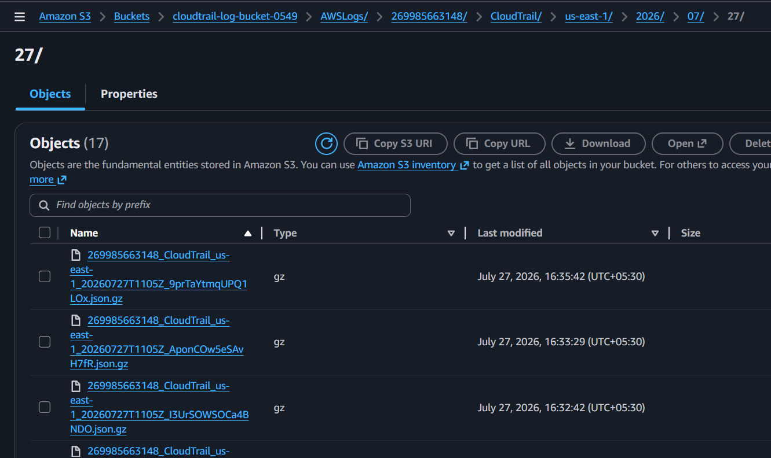

Validation 2: Verify Logs in CloudWatch
- Open CloudWatch.
- Click Log groups.
- Open:
CloudTrailLogs
- Open the latest log stream.
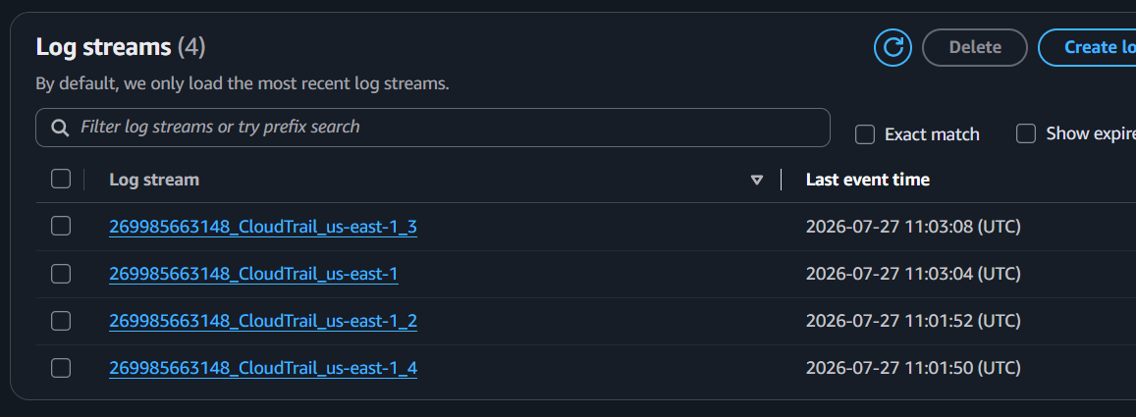
Expected Result:
CloudTrail events such as the following should be visible:
RunInstances
StopInstances
CreateBucket
CreateUser
DeleteBucket
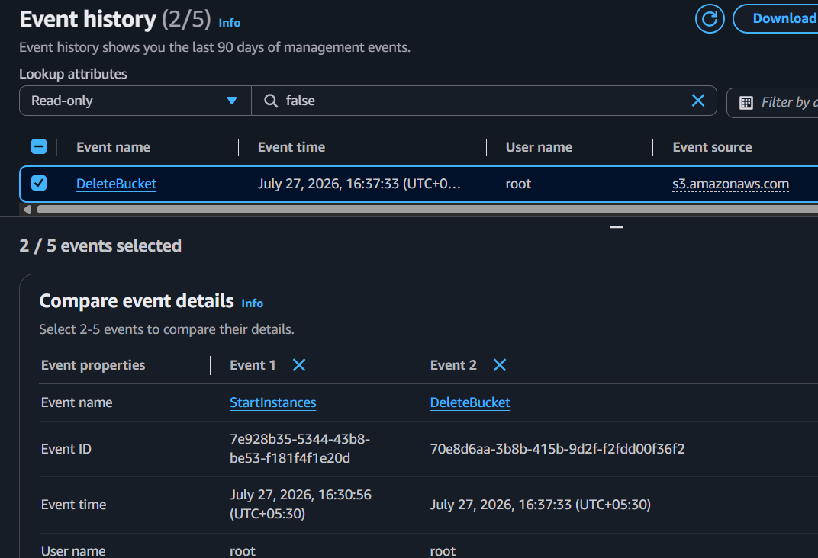

Validation 3: Verify Using AWS CLI
List available trails:
aws cloudtrail describe-trails
Lookup recorded events:
aws cloudtrail lookup-events
Expected Result:
The command should display details such as:
Event Name
Username
Event Time
Resources

Expected Outcome
✓ CloudTrail created
✓ Logs stored in S3
✓ Logs available in CloudWatch
✓ API calls recorded successfully

Task 2: Enable SNS for CloudTrail to send alerts via email

Objective

Configure Amazon SNS to notify you via email when CloudTrail-related events trigger an alarm or EventBridge rule.
Prerequisites
- CloudTrail enabled ✅
- Verified email address
- Access to Amazon SNS

Implementation Steps

Step 1: Create SNS Topic
Open
SNS
Click
Create Topic
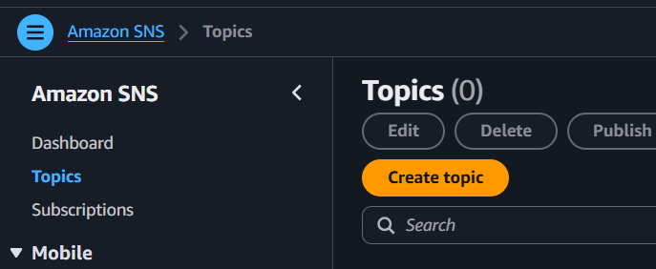
Type : Standard
Topic Name : CloudTrailAlerts
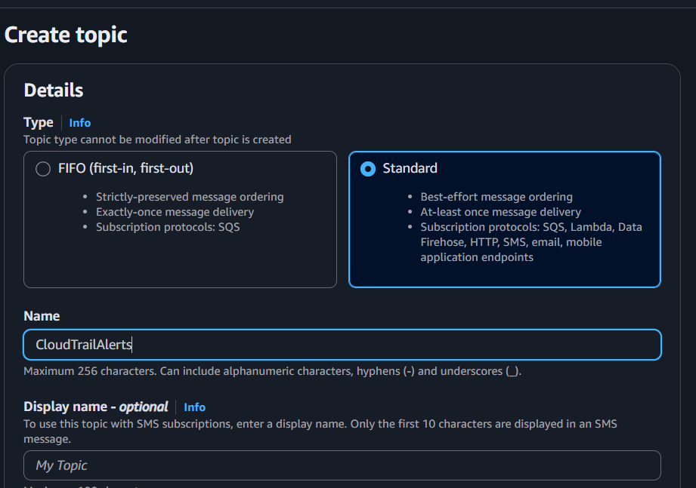
Create.
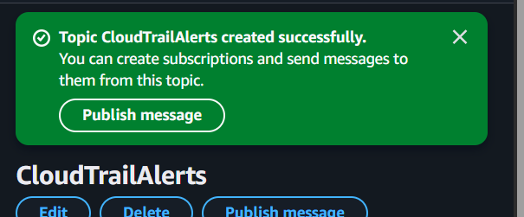

Step 2: Create Email Subscription
Inside Topic
Click
Create Subscription
Protocol
Email
Endpoint
your-email@gmail.com
Create Subscription.
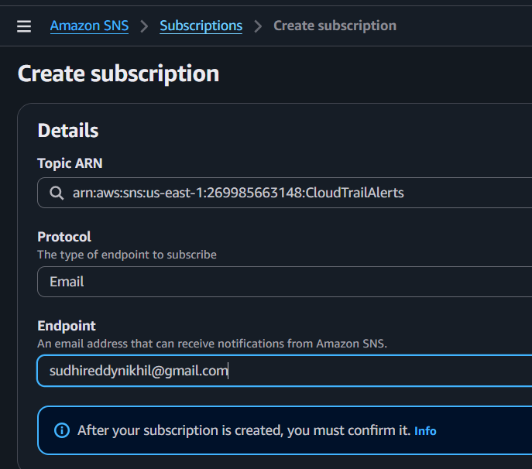
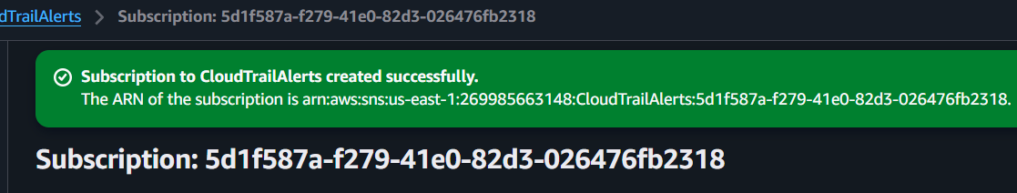

Step 3: Confirm Email
Open Gmail.
Click
Confirm Subscription
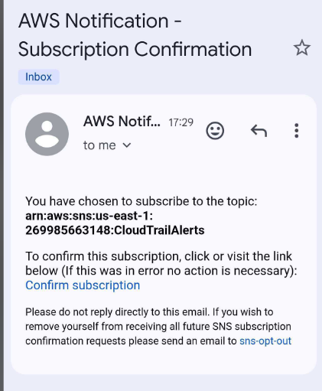
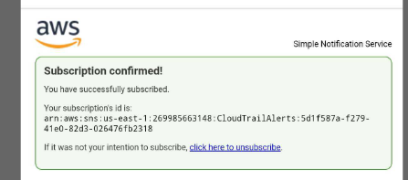

Step 4: Create EventBridge Rule
- Open EventBridge
- Create a new rule.
- Select Advanced builder (instead of Enhanced builder).
Then configure it as follows:
- Rule name: CloudTrail-SNS-Alerts
- Event bus: default
- Rule type: Rule with an event pattern
- Event source: AWS events
- Event pattern: AWS API Call via CloudTrail
- Target: SNS Topic
- SNS Topic: CloudTrailAlerts
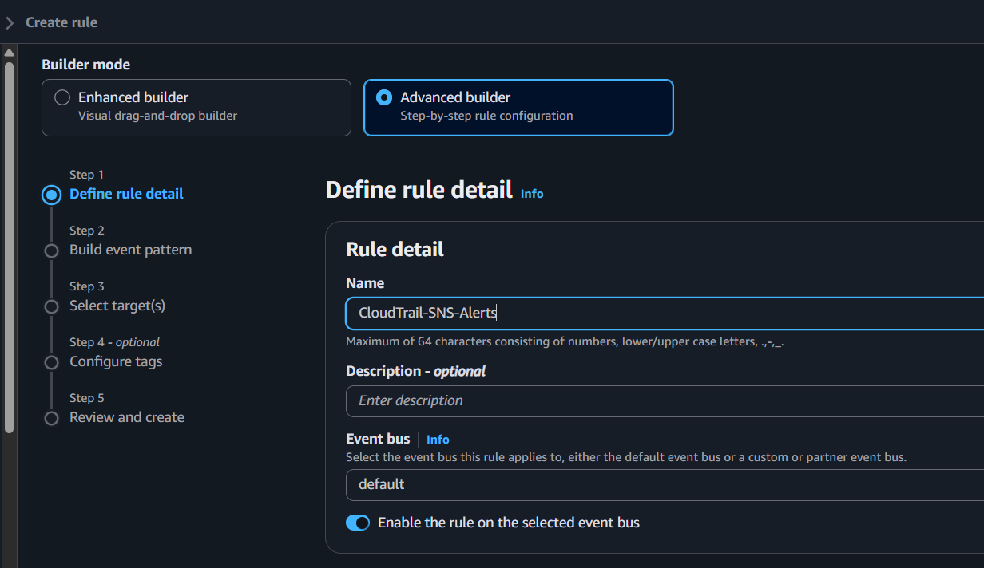

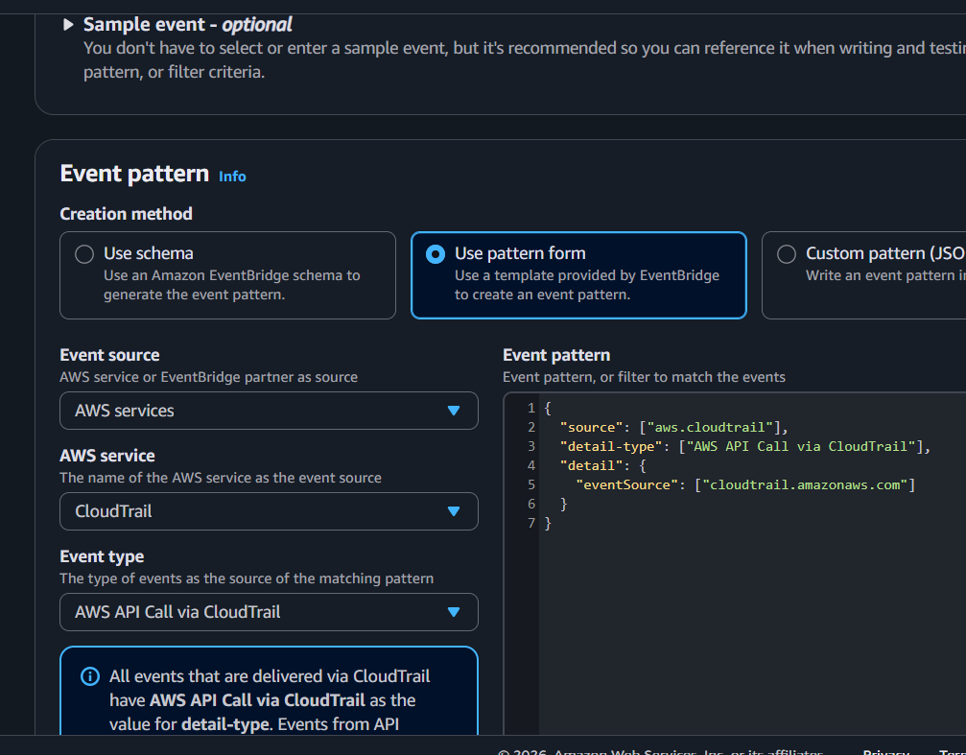
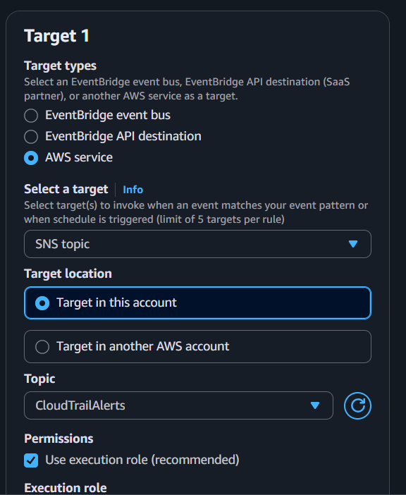
Validation

Step 1: Confirm SNS subscription
Go to:
SNS → Topics → CloudTrailAlerts → Subscriptions
The subscription status should be:
Confirmed
If it shows PendingConfirmation, check your email and click the confirmation link.

Step 2: Generate a CloudTrail event
Perform one of these actions:
- Start an EC2 instance
- Stop an EC2 instance
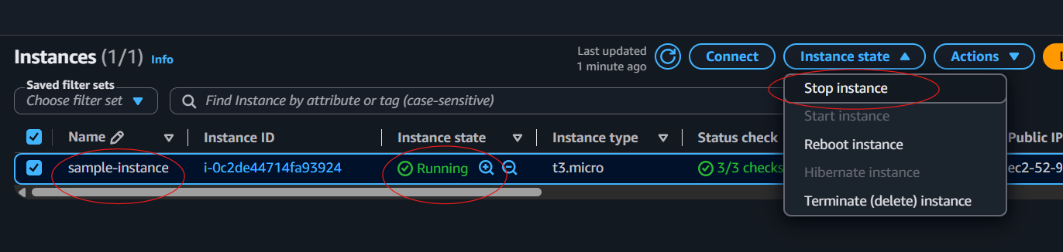
- Create/Delete an S3 bucket
- Create an IAM user

Step 3: Wait
Wait about 1–2 minutes.

Step 4: Check your email
You should receive an email from Amazon SNS containing the CloudTrail event.

Expected Result
✓ SNS Topic created
✓ Email subscription confirmed

Task 3: Configure CloudWatch monitoring and record CPU utilization and other EC2 metrics

Objective
Monitor EC2 instance metrics using CloudWatch.

Implementation

Steps
- Open CloudWatch.
- Click Metrics.
- Select Classic metrics.
- Click browser
- Select EC2.
- Click Per-Instance Metrics.
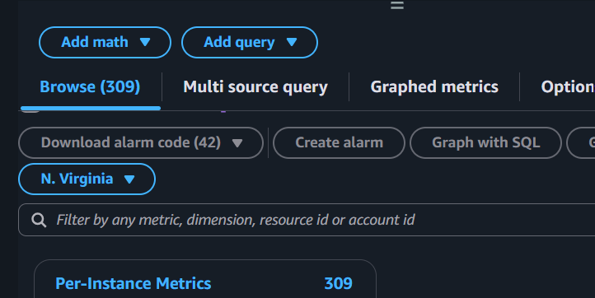
- Find your EC2 instance.
- Select CPUUtilization and the other metrics.
You should see metrics such as:
- ✅ CPUUtilization
- ✅ NetworkIn
- ✅ NetworkOut
- ✅ DiskReadBytes
- ✅ DiskWriteBytes
- ✅ StatusCheckFailed
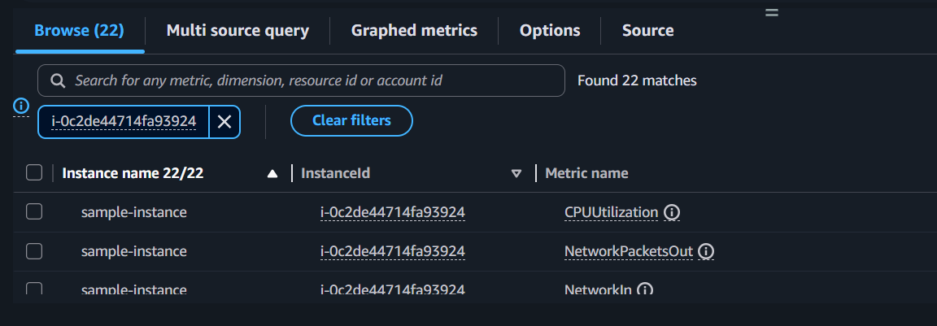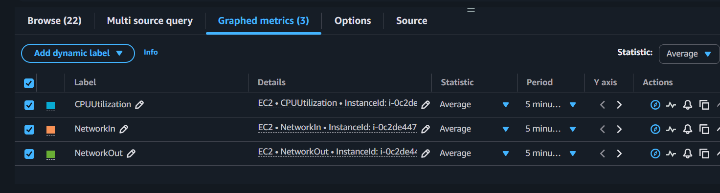

Validation
Open
CloudWatch
→ Metrics
Graphs should display.
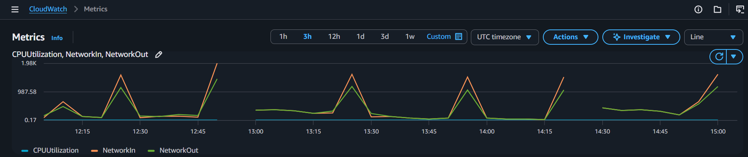

Expected Result
Metrics collected successfully.

Task 4: Create an alarm if CPU utilization exceeds 70%

Objective
Send an email alert when CPU usage is greater than 70%.

Implementation

Step 1: Open CloudWatch
- Sign in to the AWS Management Console.
- Navigate to CloudWatch.

Step 2: Open Alarms
- In the left navigation pane, click Alarms.
- Click All alarms.
- Click Create alarm.
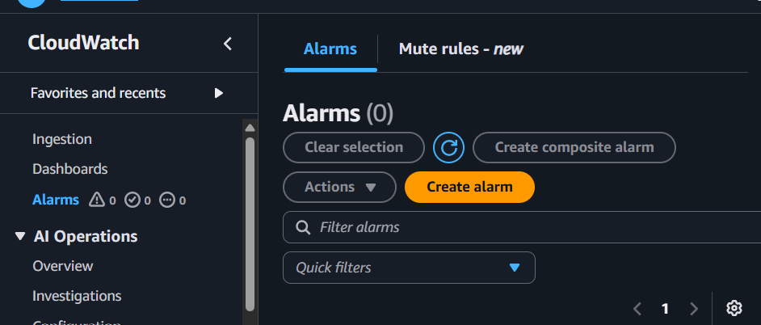

Step 3: Select Metric
- Click Select metric.
- Select AWS/EC2.
- Click Per-Instance Metrics.
- Select your EC2 Instance ID.
- Select the metric CPUUtilization.
- Click Select metric.
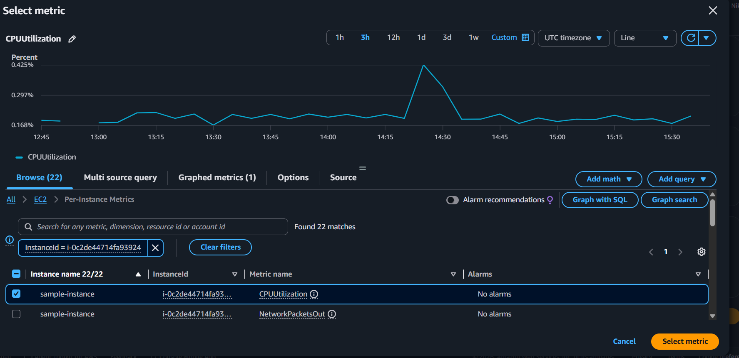

Step 4: Configure Alarm Conditions
Configure the following:
Setting | Value
Statistic | Average
Period | 5 Minutes
Threshold type | Static
Whenever CPUUtilization is | Greater than
Threshold value | 70
Click Next.
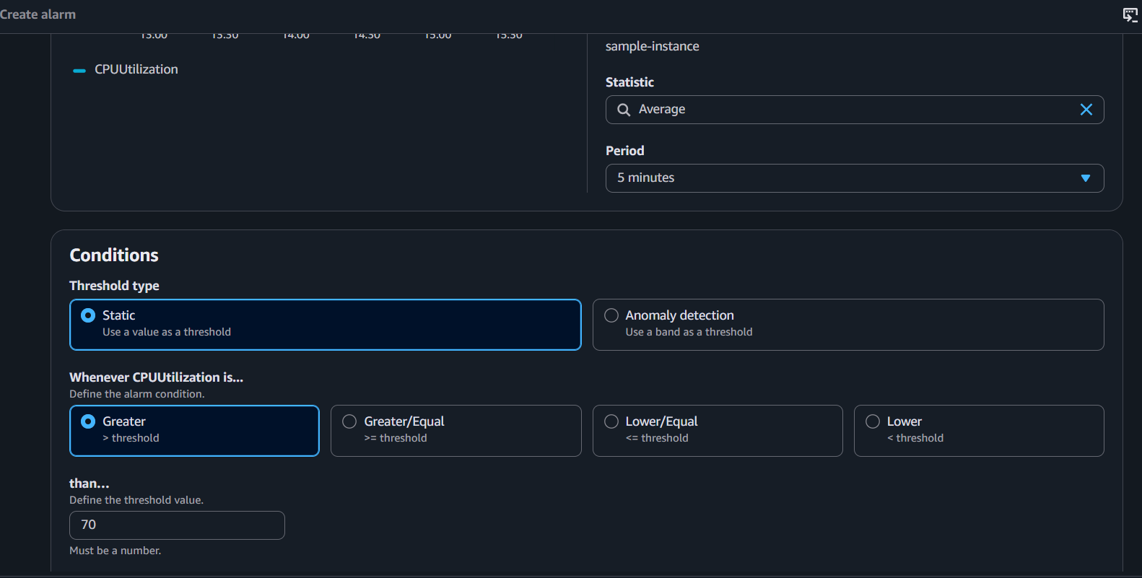

Step 5: Configure Notifications
Under Notification:
- Alarm state trigger: In alarm
- Notification type: Select an existing SNS topic
- SNS Topic: CloudTrailAlerts
Click Next.
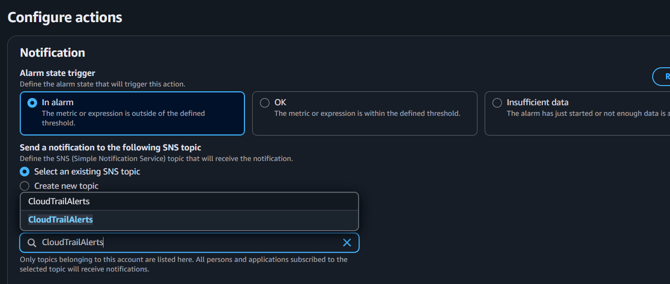

Step 6: Configure Alarm Name
Alarm Name
EC2-CPU-High-Alarm
Description
Send an email alert when EC2 CPU utilization exceeds 70%.
Click Next.
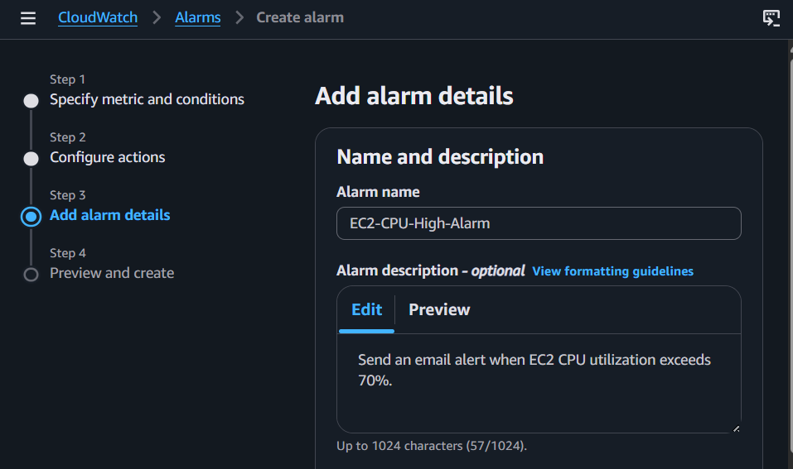

Step 7: Review
Review all settings.
Click Create alarm.

Validation Steps

Validation 1 – Verify Alarm Creation
Go to:
CloudWatch → Alarms → All alarms
Verify:
- Alarm Name: EC2-CPU-High-Alarm
- State: OK

Expected Result
The alarm is created successfully and is initially in the OK state.
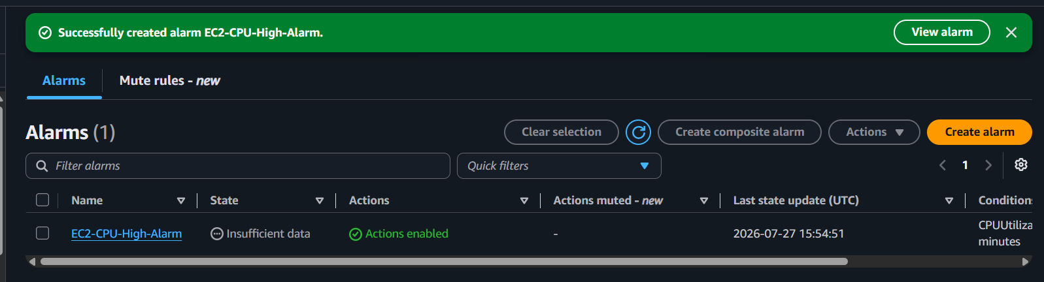

Validation 2 – Generate CPU Load
Connect to your Amazon Linux 2023 EC2 instance.

Install Stress Tool
sudo dnf install -y stress
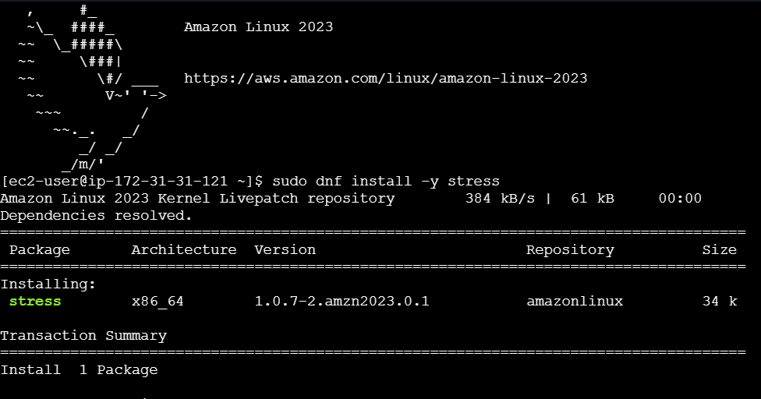

Generate CPU Load
stress --cpu 2 --timeout 300
This generates CPU load for 5 minutes.
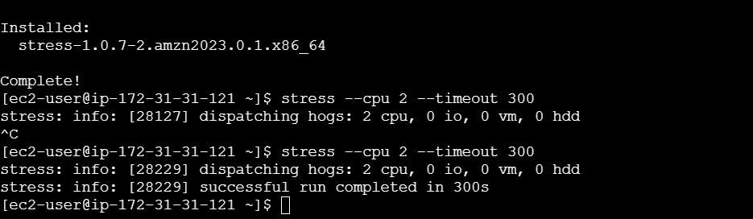

Validation 3 – Verify Alarm State
After approximately 5–10 minutes:
Go to:
CloudWatch → Alarms → All alarms
Verify the alarm state changes:
OK
↓
IN ALARM

Expected Result
The CloudWatch alarm enters the In alarm state because CPU utilization exceeds 70%.
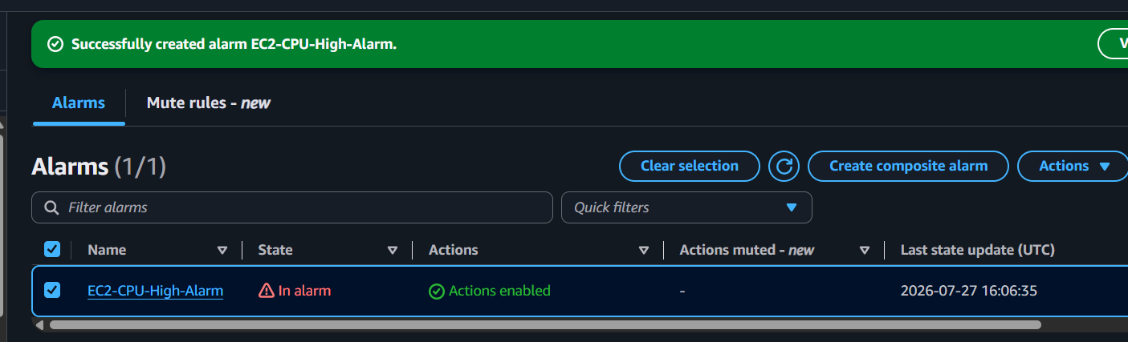

Validation 4 – Verify Email Notification
Open the email account subscribed to the SNS topic.
Verify that an email notification is received from Amazon SNS indicating that the alarm entered the ALARM state.

Expected Result
An email notification is received successfully.
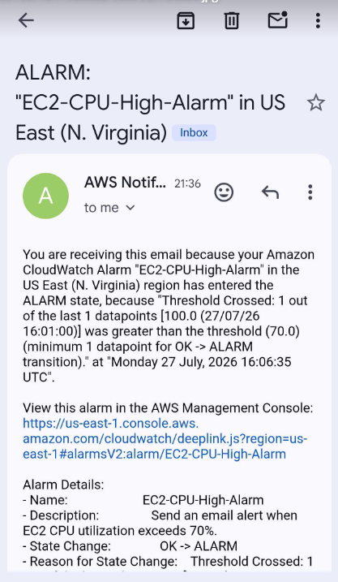

Expected Architecture
High CPU Usage
│
▼
CloudWatch Metric (CPUUtilization)
│
▼
CloudWatch Alarm (>70%)
│
▼
SNS Topic (CloudTrailAlerts)
│
▼
Email Notification

Expected Output
- ✅ Alarm created successfully.
- ✅ Alarm state changes from OK to In alarm when CPU usage exceeds 70%.
- ✅ Email notification is received through SNS.

Expected Result
✓ Alarm state changes
✓ Email notification received

Task 5: Create a Dashboard to monitor the Tomcat service and send an alert if it stops

Objective
Display Tomcat status on a CloudWatch dashboard and alert when the service is not running.
Note: CloudWatch cannot monitor a Linux service directly. Install the CloudWatch Agent and configure it to collect process metrics (or publish a custom metric) for the Tomcat process.

Implementation
Step 1: Verify Java
java -version
If Java is not installed:
sudo dnf install java-21-amazon-corretto -y
Verify again:
java -version

Step 2: Download Tomcat
cd /opt
sudo wget https://dlcdn.apache.org/tomcat/tomcat-10/v10.1.57/bin/apache-tomcat-10.1.57.tar.gz

Extract
sudo tar -xzf apache-tomcat-10.1.57.tar.gz

Rename the directory
sudo mv apache-tomcat-10.1.57 tomcat

Give execute permission
sudo chmod +x /opt/tomcat/bin/*.sh

Start Tomcat
sudo /opt/tomcat/bin/startup.sh

Verify
ps -ef | grep tomcat
or
ss -tulnp | grep 8080
Then open:
http://<EC2-Public-IP>:8080

If the Tomcat welcome page appears, the installation is successful.
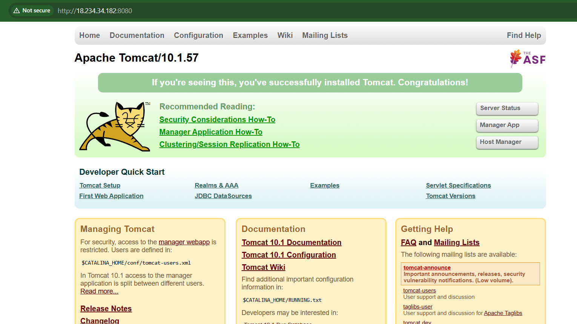
Step 1: Attach IAM Role to EC2
Your EC2 instance must have an IAM role with the following policy:
CloudWatchAgentServerPolicy

Verify
- Go to EC2 Console.
- Select your EC2 instance.
- Click the Security tab.
- Check the IAM Role field.

If no IAM role is attached
- Go to IAM → Roles → Create role.
- Trusted entity: AWS Service.
- Use case: EC2.
- Click Next.
- Search for:
CloudWatchAgentServerPolicy
- Select it.
- Click Next.
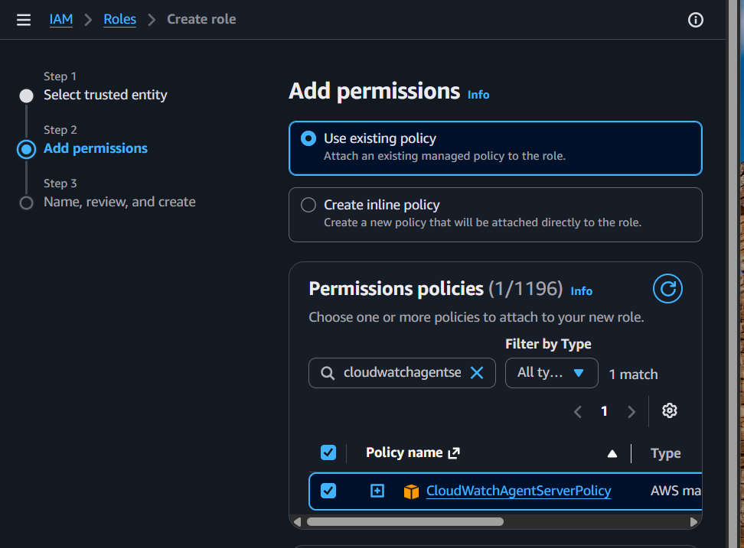
- Role name:
CloudWatchAgentRole
- Create the role.
- Return to EC2 → Actions → Security → Modify IAM role.
- Select CloudWatchAgentRole.
- Click Update IAM role.
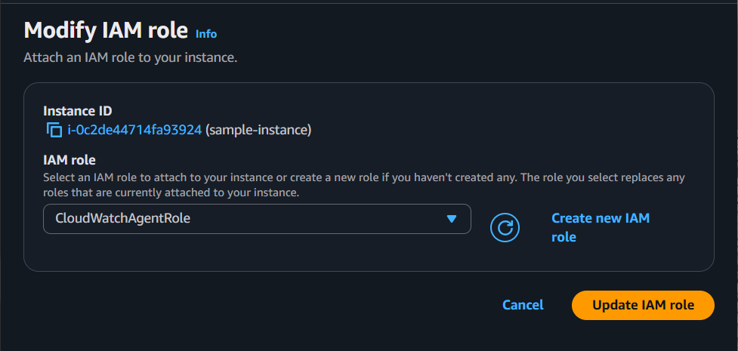
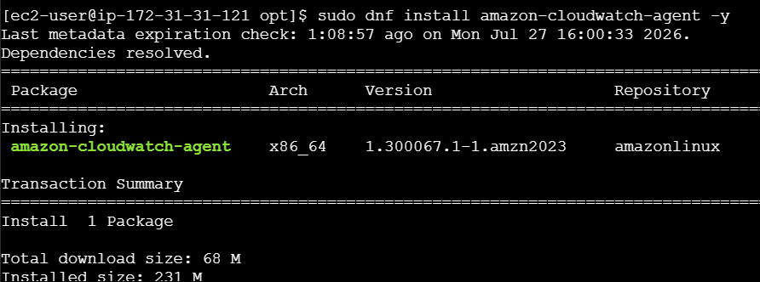

Next implementation steps are

1. Install and configure the CloudWatch Agent on the EC2 instance.
Install the CloudWatch Agent
On your EC2 instance, run:
sudo dnf install amazon-cloudwatch-agent -y
Verify the installation:
rpm -qa | grep amazon-cloudwatch-agent
You should see output similar to:
amazon-cloudwatch-agent-<version>
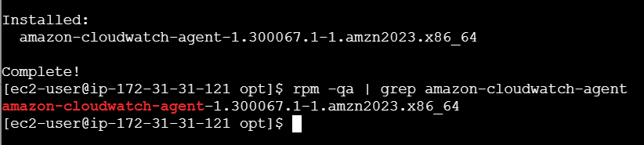

- Configure it to publish a metric indicating whether the Tomcat process is running.
- Create a CloudWatch Dashboard.
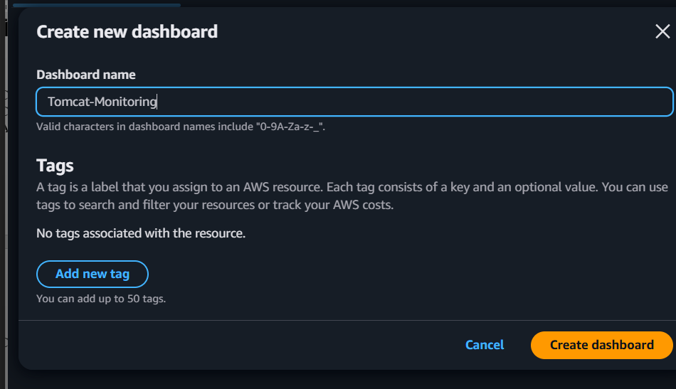

3. Add a widget for the Tomcat running metric.
Line graph widget
Select:
Line
Metric:
Custom namespaces
→ Tomcat
→ pid_count
This shows the history:
1 ─────────────── Tomcat Running

0 ─────── Tomcat Stopped
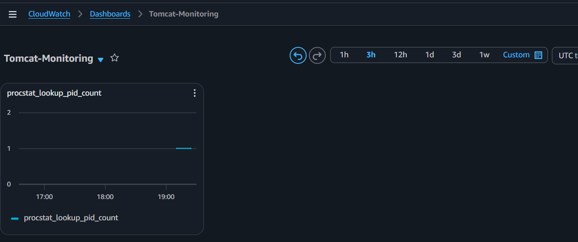

4. Create a CloudWatch Alarm:
  - Trigger when the process count becomes 0.
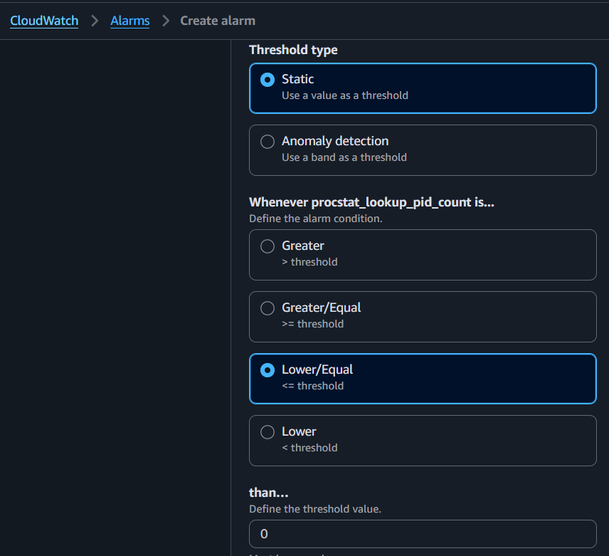
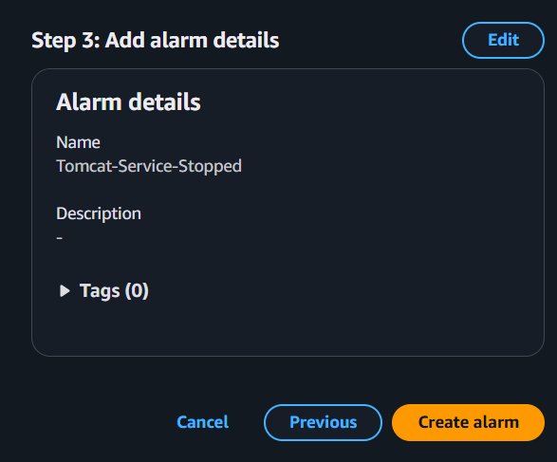
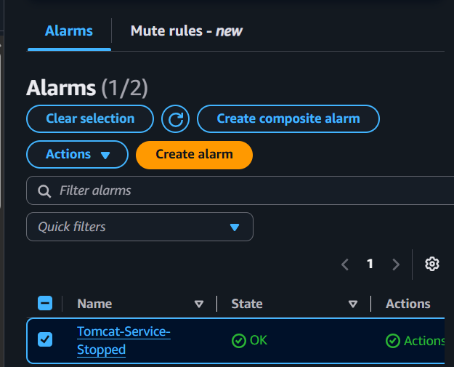
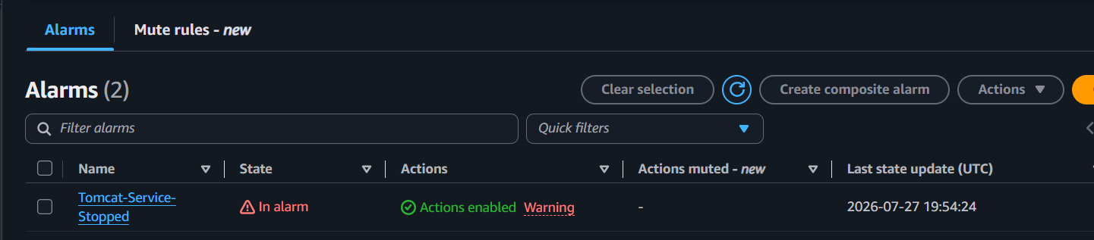
- Send notifications to the SNS topic:
CloudTrailAlerts
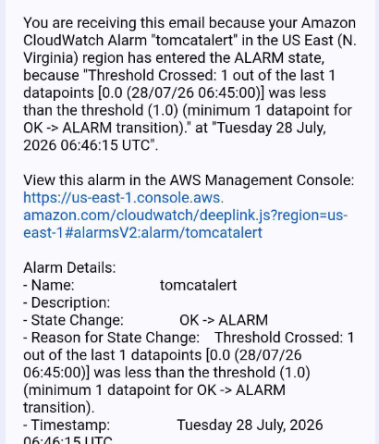

Validation
Stop Tomcat:
sudo systemctl stop tomcat
Check:
systemctl status tomcat
Dashboard should show the service as stopped (process count 0), the alarm should enter the ALARM state, and an email notification should be sent.
Restart:
sudo systemctl start tomcat
The dashboard should recover and the alarm should return to OK.
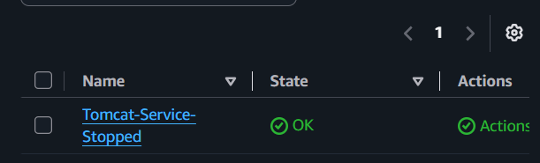

Expected Result
✓ Dashboard displays Tomcat status
✓ Alarm triggers when Tomcat stops
✓ Email notification received

Task 6: Create a Dashboard to monitor the Nginx service and send an alert if it stops

Objective
Display Nginx status on a CloudWatch dashboard and alert when the service is not running.
As with Tomcat, use the CloudWatch Agent to publish a metric for the Nginx process.

Implementation
SG traffic rule with port number 80
first need to install nginx using command “sudo dnf install nginx -y”
Start and enable Nginx
sudo systemctl start nginx
sudo systemctl enable nginx

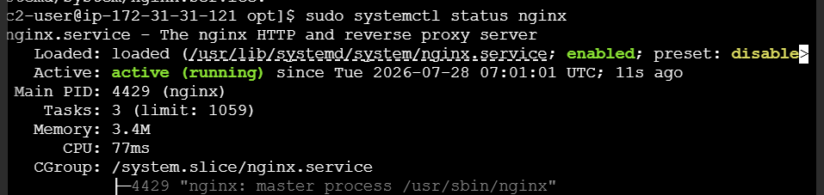

1. Configure the CloudWatch Agent to monitor the Nginx process.
Verify the metric
- Go to CloudWatch → Metrics.
- Open the namespace where procstat metrics are stored (for example, CWAgent).
- Find the metric:
  - pid_count
  - pattern = nginx
When Nginx is running, pid_count should be 1 or more.

2. Publish a custom metric indicating whether the process is running.
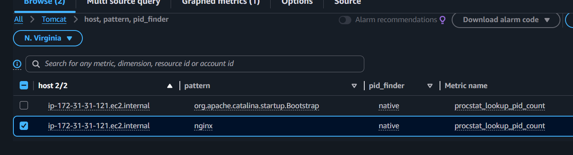

3. Create or update a CloudWatch Dashboard.
step 3.1: Open CloudWatch
- Sign in to the AWS Console.
- Go to CloudWatch.
- In the left menu, click Dashboards.

Step 3.2: Choose a Dashboard
- If you already created a dashboard for Tomcat, click that dashboard.
- If you don't have one, click Create dashboard, give it a name (for example, Application-Monitoring), and click Create dashboard.
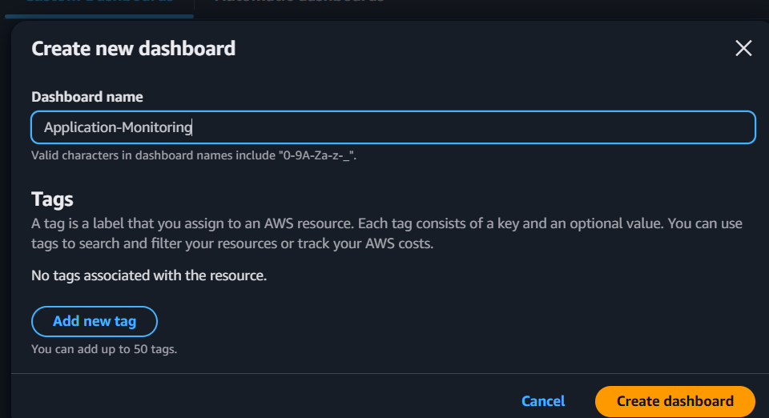

4. Add a widget for the Nginx process metric.
step 4.1: Add a Widget
- Click Add widget.
- Select Line (or Number, if your lab specifically asks for a number widget).
- Click Next.
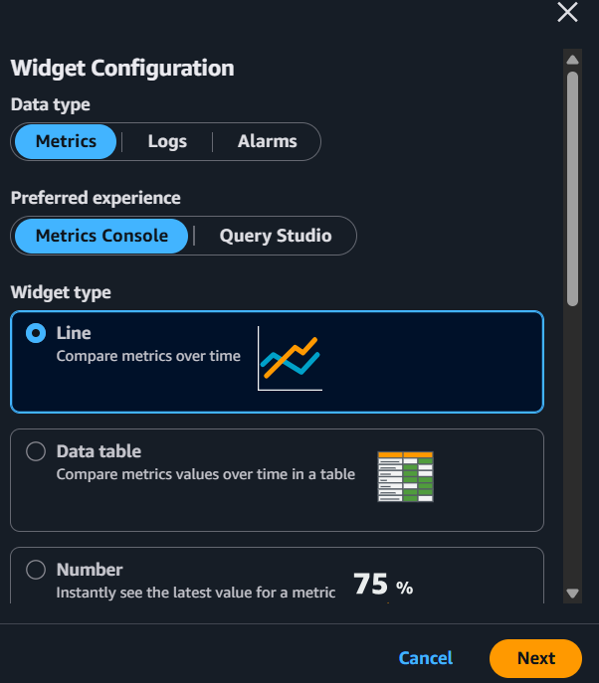

Step 4.2: Select the Metric
- Select the namespace Tomcat (because your CloudWatch Agent is publishing metrics there).
- Open Metrics with dimensions.
- Select procstat.
- Find the metric where:
  - Metric name: pid_count
  - pattern: nginx
- Check the box next to that metric.
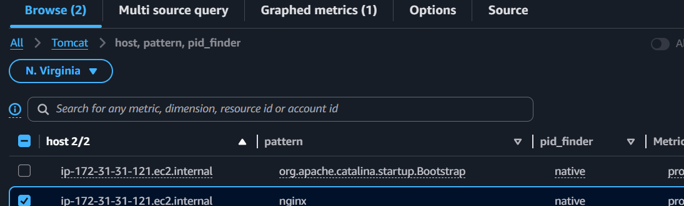

Step 4.3: Finish
- Click Create widget.
- Click Save dashboard.

5. Create the Alarm

5.1: Open the metric
- Go to CloudWatch → Metrics.
- Open the Tomcat namespace.
- Select the procstat_lookup_pid_count metric for nginx.
- Click Create alarm.

5.2: Specify the metric and conditions
Configure the alarm as follows:
- Statistic: Average
- Period: 1 minute (60 seconds)
- Threshold type: Static
- Whenever procstat_lookup_pid_count is: Lower than
- Threshold value: 1
This means:
- 1 = Nginx is running ✅
- 0 = Nginx is stopped ❌ → Alarm triggers
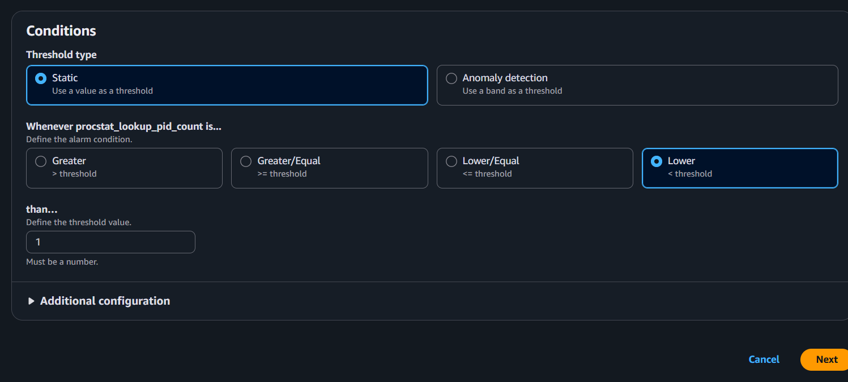

5.3: Configure actions
Under Notification:
- Alarm state trigger: In alarm
- Select an existing SNS topic
- Choose the same SNS topic you used for the Tomcat alarm.
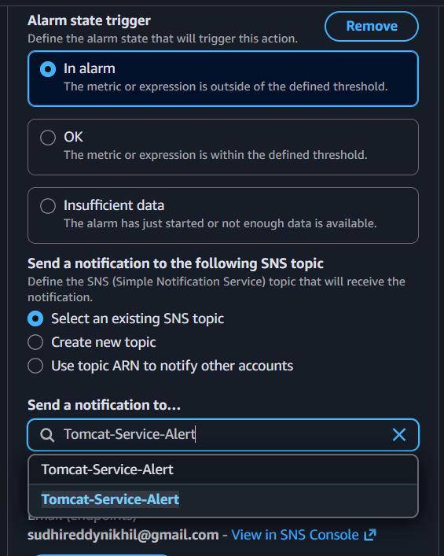
Click Next.

5.4: Add a name
For example:
Nginx-Service-Down
You can add a description such as:
Alert when the Nginx process stops.
Click Next.
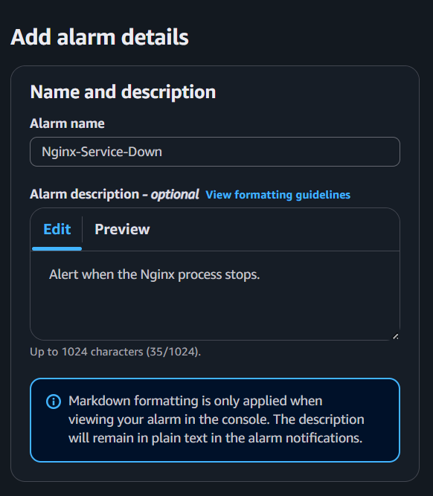

5.5: Review and create
- Review the settings.
- Click Create alarm.
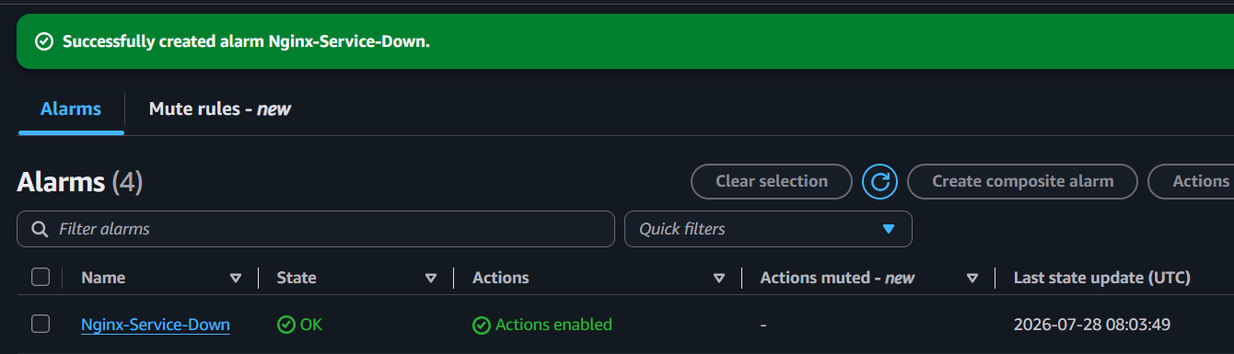

6. Use the same SNS topic:
Tomcat-service-alert

Validation
Stop Nginx:
sudo systemctl stop nginx
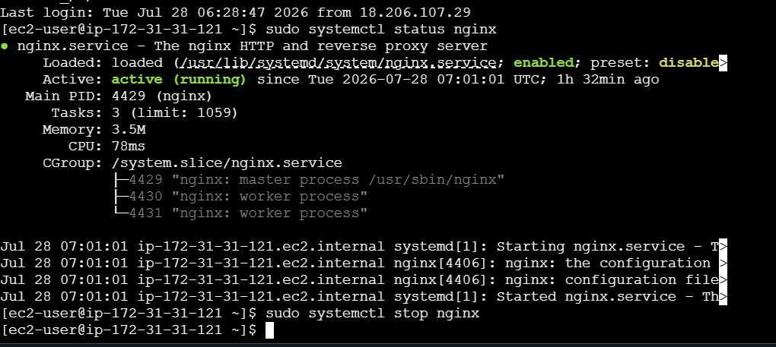
Verify:
systemctl status nginx
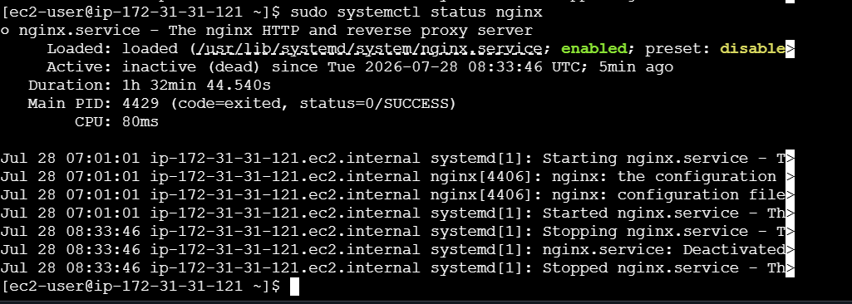
The dashboard should show the service as stopped, the alarm should enter the ALARM state, and an email notification should be delivered.
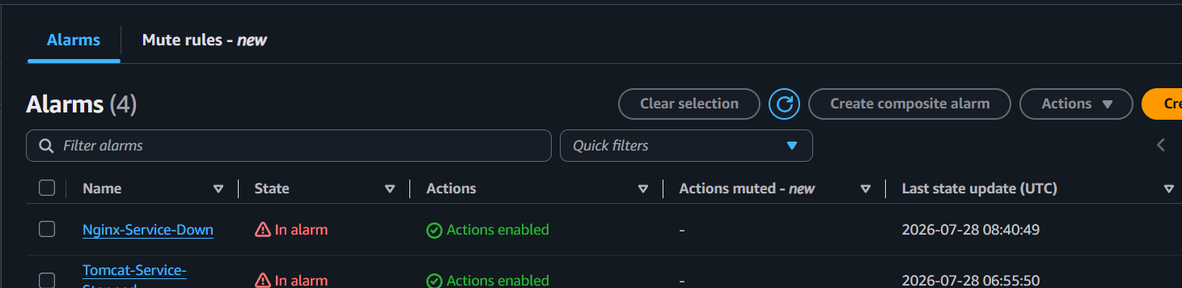
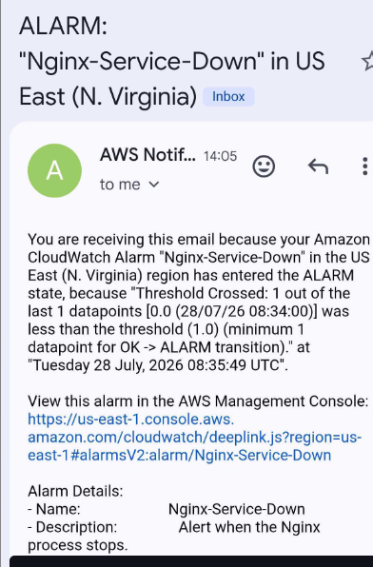
Restart:
sudo systemctl start nginx
The alarm should return to OK.
